needs
needs |  | 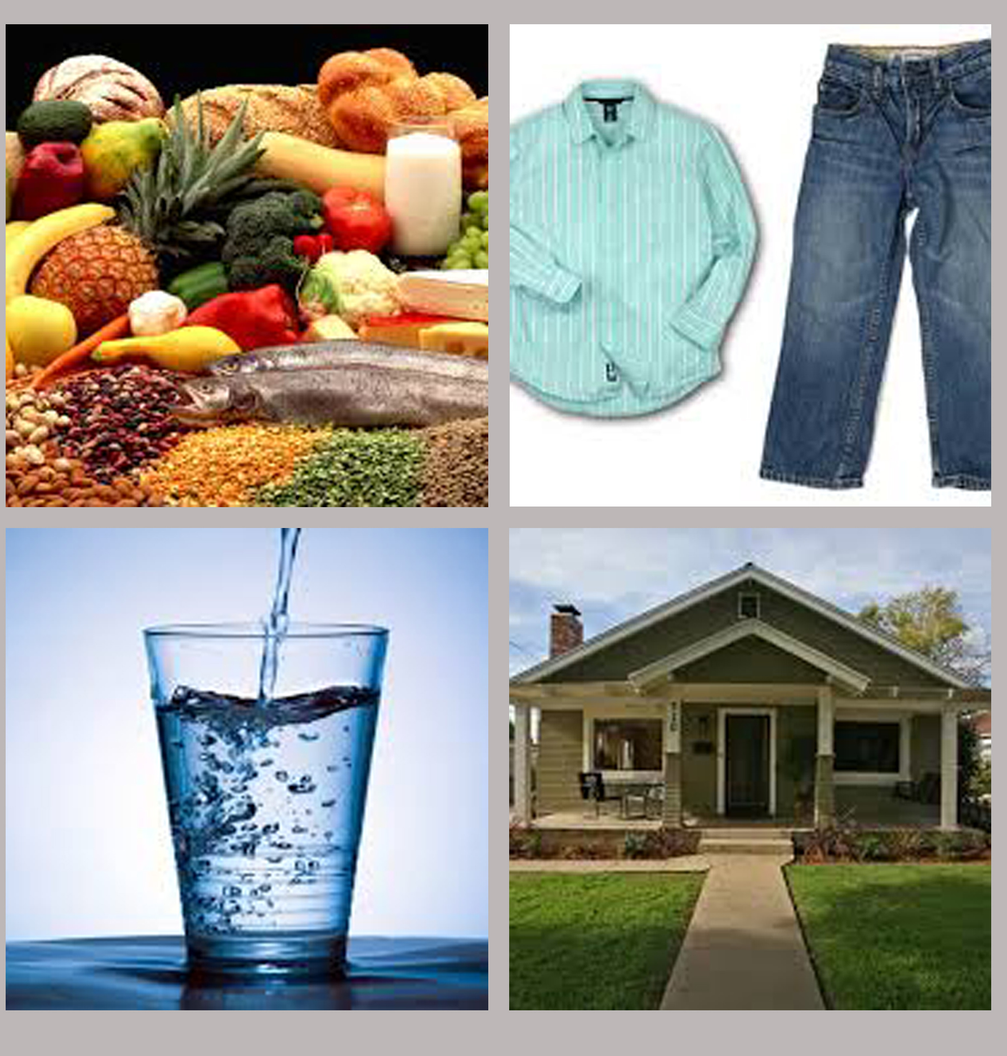
needs |  |  | things that you have to have
wants
wants |  | 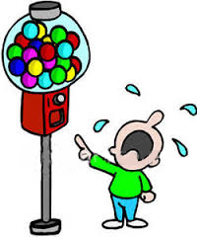
wants |  |  | to wish for, or greatly desire things
job
job |  | 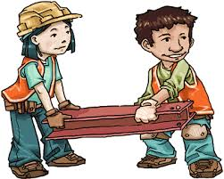
job |  |  | a task or a chore
money
money |  | 
money |  |  | the coins and bills that people use to buy things
earn
earn |  | 
earn |  |  | to receive payment for work done
tools
tools |  | 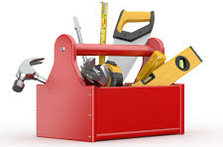
tools |  |  | equipment that you can use to do a particular job
coins
coins |  | 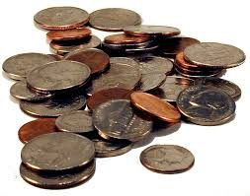
coins |  |  | small pieces of metal stamped with a design and used as money
currency
currency |  | 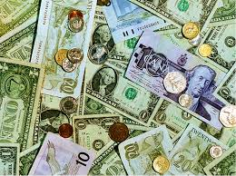
currency |  |  | the form of money used in a country
shelter
shelter |  | 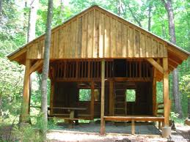
shelter |  |  | a place that gives cover or protection

